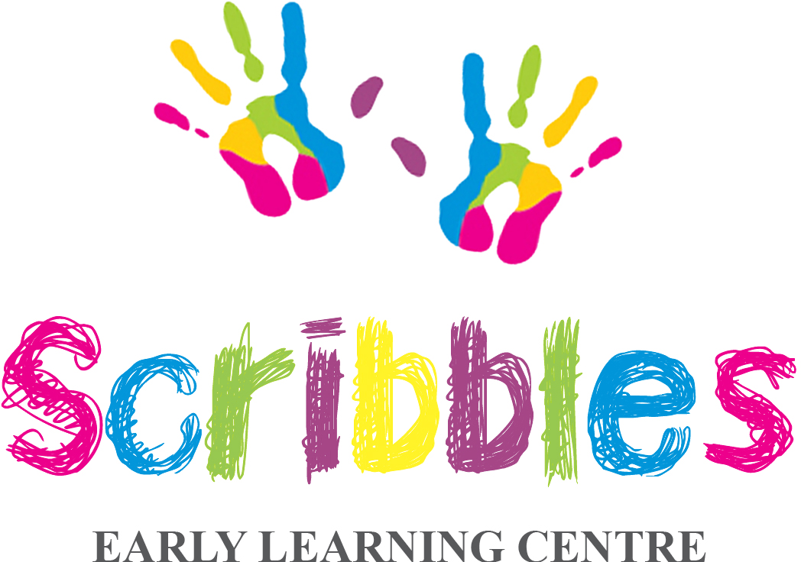
Nursery Manager — Full Time
Scribbles Early Learning Centre, Harrow HA2 0NQ
Salary: £35,000 – £40,000 per annum, dependent on experience
Hours: Full time, all year round, 40 hours per week, Monday to Friday
Start date: Immediate start

About Us
At Scribbles Early Learning Centre, we believe every child's journey starts with curiosity, creativity, and care. Rated Good by Ofsted, our nurturing setting supports children aged 0–5 years through the EYFS curriculum, play-based learning, and our trusted key person system. We're a passionate, growing team, and our people are everything to us.

About the Role
We are looking for an experienced, motivated, and caring Nursery Manager to lead our team at Scribbles Early Learning Centre in Harrow. You will be responsible for the day-to-day running of the nursery, ensuring the highest standards of care, safeguarding, and education for every child, while supporting and developing your staff team.

Key Responsibilities
- Overseeing the day-to-day management and smooth running of the nursery
- Ensuring full compliance with EYFS requirements, Ofsted standards, and safeguarding policies
- Leading, motivating, and supporting the staff team, including training and development
- Building strong relationships with children, families, and colleagues
- Managing staffing, rotas, and ratios effectively
- Monitoring and maintaining high-quality standards of care and education across all age groups
- Developing and managing the nursery budget
- Promoting and marketing the nursery to support enrolment
- Acting as Designated Safeguarding Lead (or supporting the DSL)
- Liaising with parents, external agencies, and regulatory bodies as required

About You
- Full and relevant Level 3 (or above) childcare qualification – essential; Level 5 preferred
- Minimum 5 years' childcare experience
- Minimum 2 years' management experience
- Strong knowledge of the EYFS framework and safeguarding requirements
- Excellent leadership, communication, and organisational skills
- A genuine passion for early years education and childcare
- Paediatric First Aid certificate (or willingness to obtain)
- Enhanced DBS (or willingness to apply for one)

What We Offer
- Salary of £35,000 – £40,000 per annum, reflective of your experience and qualifications
- A supportive and friendly team environment
- Opportunities for continued professional development and training
- The chance to lead an exciting, newly opened setting from an early and rewarding stage

How to Apply
To apply, please download an application form from our website (www.scribbles-elc.co.uk) or email info@scribbles-elc.co.uk to request one. Please return your completed application form along with your CV and a short cover letter telling us why you'd be a great fit for Scribbles to: info@scribbles-elc.co.uk
If you have any questions, you can call us on 07561 404415 or 0208 149 7912.
We look forward to hearing from you. Early applications are encouraged — we are keen to appoint as soon as possible.
Scribbles Early Learning Centre is committed to safeguarding and promoting the welfare of children. All appointments are subject to an enhanced DBS check and satisfactory references.
www.scribbles-elc.co.uk

